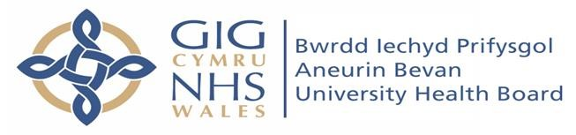

Malpas Brook Health Centre
107 Malpas Road
Newport
Gwent
NP20 5PJ
Telephone: 01633 855808
Website: www.malpasbrookhealthcentre.co.uk

Malpas Brook Health Centre is a well organised, high achieving practice which prides itself on providing excellent patient care. There is a diverse range of interests, skilled colleagues, and exceptional leadership at the helm. Development is actively encouraged, and you will be supported in the pursuit of specialist interests.

We believe in creating a safe, supportive environment for teaching and training. To help facilitate this we hold weekly clinical meetings and have structured breaks to encourage discussion of cases to aid professional development.

The practice is situated on the west side of Newport, just off Junction 26 of the M4 making the surgery an easy commute from either Cardiff or Bristol. We currently have just short of 10,000 patients and offer a comprehensive range of services to our patients.

We have a fully staffed administrative team supporting our wide range of health care professionals. Whilst Rebecca Thomas and Dr Samantha Jenkins are the qualified GP trainers with the practice, we have a large health care team, all of whom will support you during your time with us.

Currently our team consists of:
- 3 GP Partners (Dr Thomas Dr Jenkins & Dr Moore)
- 4 Salaried GP’s (Dr Cozens, Dr Beardsell, Dr Meakin & Dr Ahlawat)
- 1 Advanced Nurse Practitioner (Sian Jefferies)
- 3 Practice Nurses (Andrea Walker-Pole, Alicia Robinson, Louise Cahill)
- 2 Health Care Professionals (Zoe Currie, Emma Hewitt)
- 1 Phlebotomist (Hannah Davies)
- 1 Pharmacist (Anesha Premji)
- Practice Manager (Gareth Winter)
- Assistant Practice Manager (Stephanie Williams)
- Fully trained team of Care Navigators

Our team also work closely alongside District Nurses, Health Visitors and the Palliative Care Team to mention a few. We are engaged in weekly Multi Disciplinary Team meetings, discussing relative patients to help provide the most cohesive and effective care possible.

We also hold the contract for providing healthcare to HMP Usk, and HMP Prescoed. Both prisons are low category, and we provide morning surgery in the prison, and then remote advice in the afternoon. Any involvement in the prison healthcare, would be completely voluntary.

For any further information please contact the Practice Manager:

Mr Gareth Winter
Direct Line: 01633 855808 Ext:120
Email: gareth.winter@wales.nhs.uk

