Meddygfa Cwm Rhymni Practice
R.I.H.S.C.C
Unit 22 Lawn Ind Est
Rhymney
Gwent
NP22 5PW
Tel: 01685 700404
www.meddygfacwmrhymnipractice.org
www.facebook.com/cwmrhymnisurgery

Partners:- Drs Neil James, Andy Dalrymple, Glyn Davies, Judy Parsons, Anna Phelps, Leigh Hodges, Joe Bell

ANP’s :- Sarah Truman, Jacqueline Hadland, Sharon Smith

Practice Manager:- Alyson Jones
We are a 7 partner teaching practice with a list size of approximately 13,000 patients supported by 3 ANP’s/4 Practice Nurses/3 HCA’s and a host of administrative staff. The practice has been training for many years providing teaching to registrars and undergraduate medical students from Cardiff.
The practice main site is situated within purpose built premises at Rhymney Resource Centre with 12 bed ward on lower floor. The premises are shared with Dentist, Opticians, Pharmacy and numerous allied health services onsite including:- sexual health/podiatry/retinal screening/health visitors/district nurses/mental health. The practice has 2 branch sites located in New Tredegar & Deri all within short distance of each other and ample parking with good commuting links just off A470.
We have regular weekly meetings such as clinical, quality improvement, management, significant events, palliative care, safeguarding and QAIF, which trainees are encouraged to take an active role The practice utilises VISION computer clinical system along with Docman and Lexacom. There is a dedicated trainee room at the sites.

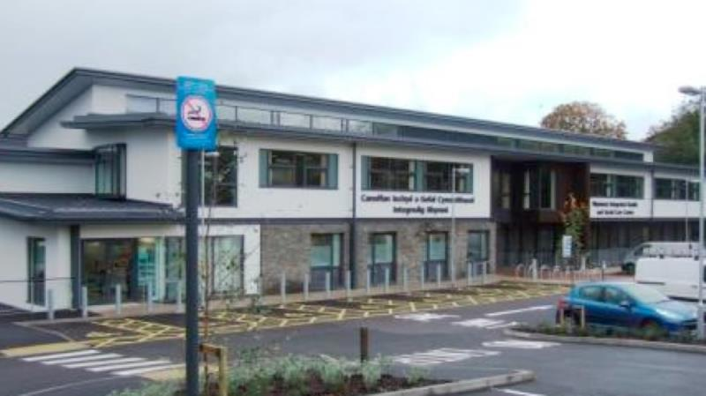
Rhymney Surgery

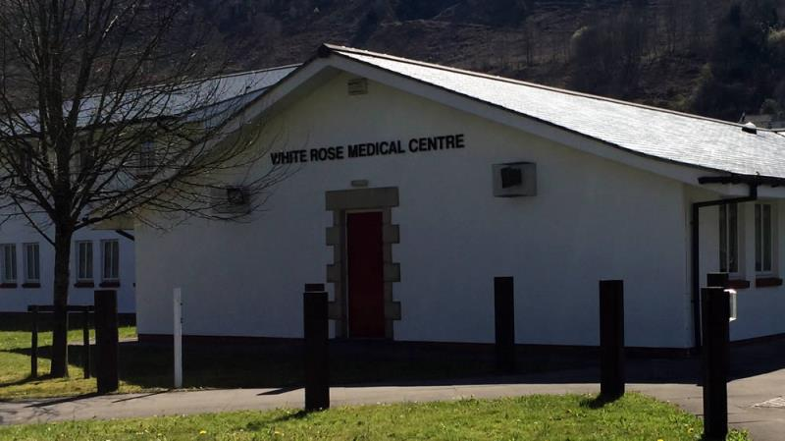
New Tredegar Medical Centre & Deri Surgery
The Medical Centre at New Tredegar
This building is also a purpose built which is light, spacious, with easy access for wheelchair users and children in prams or pushchairs, ample car parking space adjacent to the building with a Pharmacy situated within grounds for convenience.

