Blaina Medical Practice
Blaina
Abertillery, NP13 3AT

www.blainamedicalpractice.co.uk
www.facebook.com/blainamedicalpractice

GP Trainers: Dr Tom Evans (MRCGP 2013)
Dr Helen Davey (MRCGP 2009)

Practice Manager: Beth McDermott
beth.mcdermott@wales.nhs.uk
01495 290325

Blaina Medical Practice is a medium size practice with a stable list size of 6,500 patients based in the Blaenau Gwent Valleys, close to the Brecon Beacons National Park. We are a single site practice in a modern building which has been recently renovated to a high standard to include new consultation rooms, a new reception area and doctor’s lounge. The practice is well-run, has a manageable workload and serves a friendly practice population with a strong emphasis on community values. Blaina is easily commutable from Cardiff or Newport, and is close to the Brecon Beacons, Abergavenny and the Usk Valley (our doctors currently live in Cardiff, Newport and Abergavenny).

You’ll enjoy working alongside an excellent clinical team comprising of 2 full time GP Partners, three salaried GPs, a prescribing practice nurse, a health care assistant, phlebotomists, NCN pharmacist, NCN mental health practitioner and an excellent administrative team.

As well as supporting GP trainees, the practice provides undergraduate teaching for final year medical students from Cardiff University. We are enthusiastic about teaching and aim to provide a supportive environment for our GP Trainees. We have two Trainers within the practice but all of our clinical team are happy to support our Trainees.

We are a sociable practice and the GPs meet up over lunch in the lounge most days. We also have regular partnership meetings along with clinical and quality improvement meetings, and trainees are invited to participate in these. You will be encouraged to take part in all aspects of practice life and to become part of the team.

If you would like to know more then please get in touch. You would be very welcome to come and have a look around and meet us on a completely informal basis, or arrange an informal chat remotely.
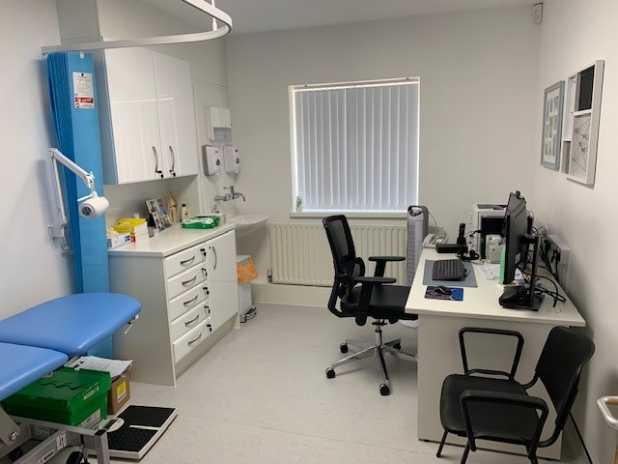

Picture 1: New consultation rooms
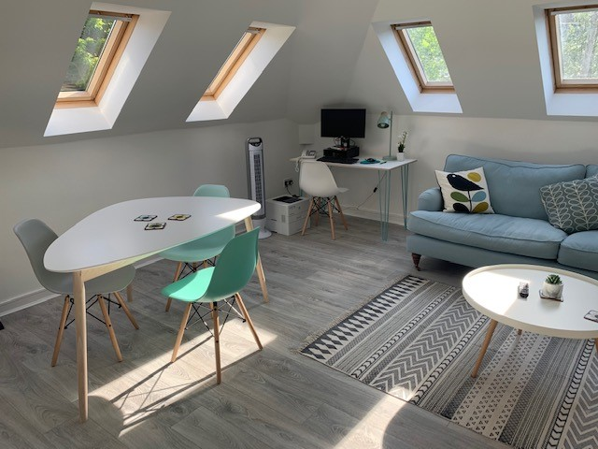
Pictures 2&3: New doctor’s lounge

