Brecon Road, Abergavenny, Monmouthshire, NP7 5AQ
Telephone 01873 859 000
www.oldstationsurgery.nhs.uk

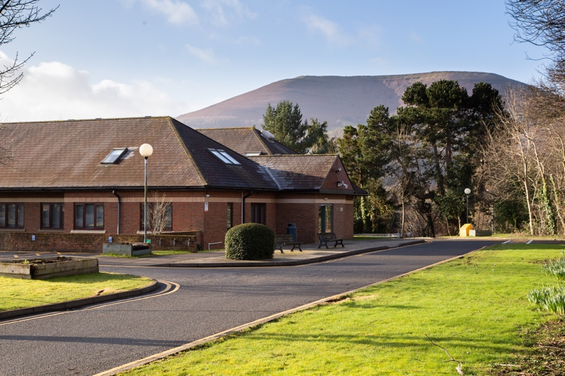

Trainers: Dr Megan Rose, Dr Lauretta Hughes, Dr Jonathan Jacoby

Old Station Surgery is a large 9 Doctor practice situated in the market town of Abergavenny on the edge of the Brecon Beacons National Park. Abergavenny is famous for its fantastic scenery and the beautiful Black Mountains provide a stunning backdrop to the surgery. We have a spacious purpose-built premise which has recently undergone a significant refurbishment in 2019. There are also excellent parking facilities on site for both doctors and patients.

We have a list size of 10,500 patients and are a dispensing practice which means rural patients can collect their medication directly from us.

Abergavenny provides a great base for walking, cycling and exploring the great outdoors. The town hosts an annual food festival where foodies come from all over to sample the wonderful local produce. There is also a wealth of great restaurants and pubs to enjoy.

Abergavenny has very good rail and road links and is within easy commuting distance to Cardiff, Newport, Hereford and Bristol.

Surgery Opening Hours

Monday – Friday 08.00 – 18.30

The Team

We are a large team of 5 partners, 4 Salaried GPs, 2 Advanced Nurse Practitioners and a Practice Pharmacist who will be able to help and support you throughout your placement. We also have a large complement of practice nurses, health care assistants, reception and administrative staff. We have a wide range of clinical and non-clinical specialist interests and provide specialist services for our patients.

We work closely with the wider Primary health care team including the district nurses, health visitors, midwives, community palliative care teams and mental health counsellors – most of which run their clinics from the surgery on different days of the week.

The Doctors and ANPs

Dr Megan Rose (Partner) - MBChB 1998
Dr Douglas Campbell (Partner) - MBBS 1988
Dr Lauretta Hughes (Partner) - MBChB 2008
Dr Rachel Hughes (Partner) – MBChB 2010
Dr Ellis Hughes (Partner) – MBChB 2010
Dr Katherine Stoddart (Salaried GP) – MBBCh 2013
Dr Lucy Weeks (Salaried GP) - MBChB
Dr Rachel Sumner (Salaried GP) – MBChB
Dr Jonathan Jacoby (Salaried GP) – MBChB

Sarah Bayliss (Advanced Nurse Practitioner)
Liz Williams (Advanced Nurse Practitioner)

The Nursing Team

Sharon Havard - Senior Nurse
Cerys Ward - Senior Nurse
Nicola Clifford - Practice Nurse

Bev Harris - HCA
Lisa Bowden - HCA
Kim Brooks - HCA

Practice Pharmacist

Chris Peberdy

Practice Manager

Lorraine Brooks

Practice Services

We run specialist Nurse Clinics managing Diabetes, Coronary heart disease, Asthma, COPD and Hypertension. Our GPs have special interests in Women’s health, Sexual Health, Men’s Health, Musculoskeletal disease, Cardiology, Dermatology, Anticoagulation, Mental Health, Diabetes, Palliative care and Preventative Medicine.

Coil Clinics

Dr Rachel Hughes runs a coil clinic once or twice a month fitting different types of intrauterine contraceptive devices.

Minor Surgery clinics

Dr Ellis Hughes runs a minor surgery clinic once a month removing a wide range of different skin lesions.

Joint Injections

Dr Campbell performs a variety of different joint injections, and 3 other partners perform knee joint injections.
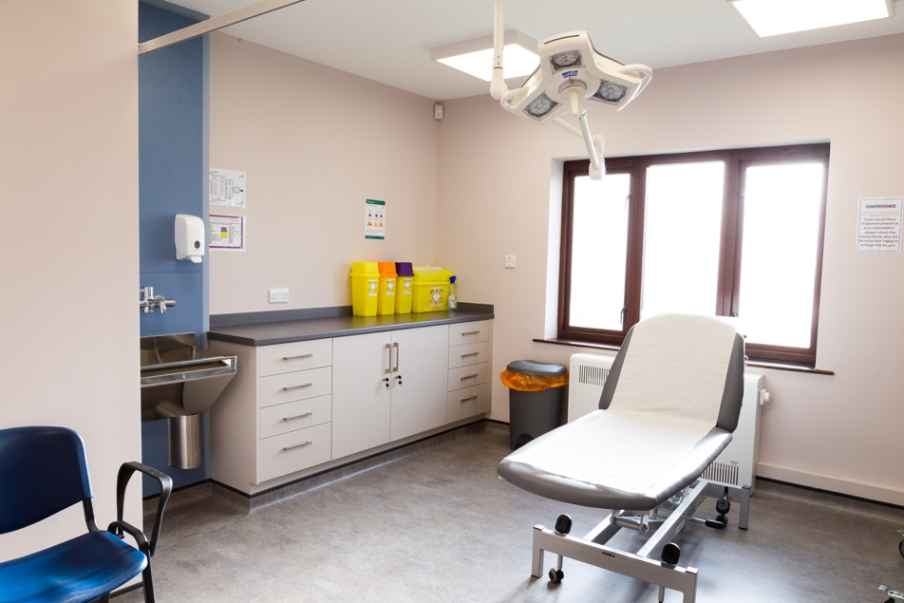

Educational Opportunities - What we can offer you…

We are a dynamic and innovative practice. We have an excellent primary health care team who have a broad mix of skills and experience which will provide you with excellent opportunities to learn about many different areas of clinical practice.

Dr Megan Rose, Dr Lauretta Hughes and Dr Jonathan Jacoby are all GP trainers therefore we have capacity to accommodate up to 3 trainees. All members of the health care team are involved in supervising trainees.
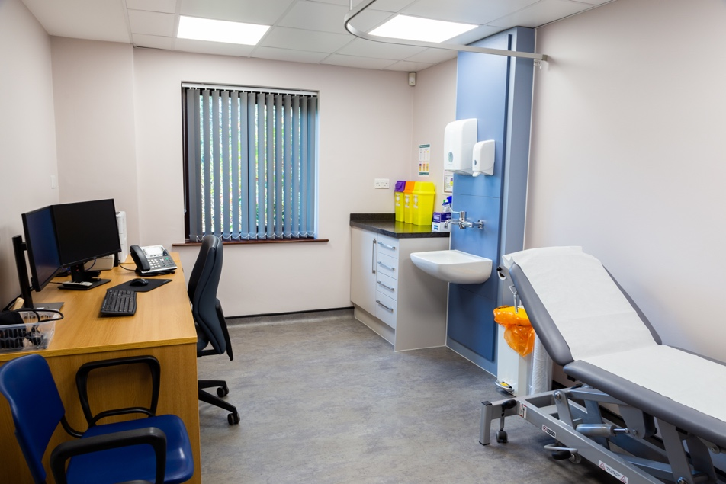
The computer system we use is EMIS Web. You will have access to a dedicated registrar consulting room. We are committed to a protected 1:1 tutorial every week with your trainer in order to help maximise your learning and identify ongoing learning needs. You will also have dedicated “hot reviews” with your trainer or supervisor every day after surgery. Your trainer or supervisor will also have blocked slots each clinic to allow time for any queries or patient reviews that you might need during the clinic.

As well as supporting GP trainees the practice provides undergraduate teaching for Cardiff medical students.

We have a weekly clinical meeting which all members of the team are invited to attend. This may consist of a short clinical presentation by an external speaker, one of the team, or a presentation of an audit or significant event.

We aim to provide a supportive learning environment to all our GP trainees. We are a friendly practice and feel we have much to offer you in training for your medical career. We hope that the variety of different experience, skills and interests of the GPs and practice team will provide registrars with a well-rounded and enjoyable learning experience.

You are welcome to come and meet us at the surgery at any time. We have a team coffee break at 10.30 every day.

Contact Us

Lorraine Brooks, Practice Manager

Tel 01873 859000

We look forward to meeting you.
For further information please see out practice website

www.oldstationsurgery.nhs.uk

